EECS 372 Project Proposal
Passenger Volume Simulation on Yamanote Line in Tokyo

Yamanote Line is the busiest commute railway line in the world, carrying on average 3.68 million passengers per day. The line circles metropolitan Tokyo, spanning 34.5 kilometers and serving 29 stations. In this project, I will use NetLogo to simulate the passenger movement on the Yamanote Line during a typical day of operation.
A route map of the Yamanote Line is shown below:
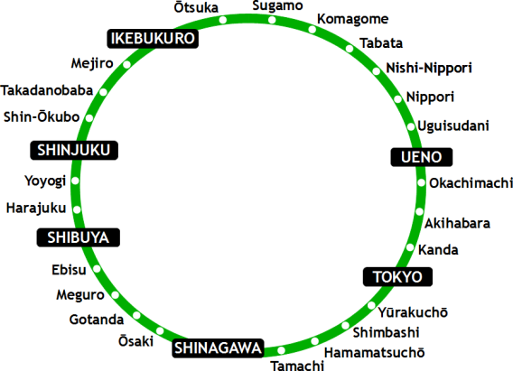
Since to model all the 29 stations could introduce too many complications and redundancy, I decided to include only the boxed stations in the diagram, namely Ikebukuro, Ueno, Tokyo, Shinagawa, Shibuya and Shinjuku.
The study of the Yamanote Line is valuable in several ways. By inspecting passenger movements on the line, we are able to observe many interesting characteristics such as:
- which sections of the line experience the most amount of traffic
- what is the ideal frequency of train operations given the passenger volume
- how passenger volume at each station changes over time
- how crowded trains become
- average time it takes for a passenger to reach his or her destination
The results and study methods could possibly prove applicable to other railway systems in the world. The model has the potential of becoming greatly helpful for transportation planners.
This model is a great fit for ABM because of two intrinsic natures of such railway systems. First, movement is an essential part of the system. ABM provides the mechanism for both formulating and visualizing movements. Second, lots of interactions take place among different agents and these interactions are fairly rule-governed (trains move, passengers embark and disembark) and unpredictable by equations (random) at the same time.
On the design level of the model, I decided to include both agents and patches. To better visualize them, they are listed below with individual description and properties:
Agents:
- Passengers: passengers who take the train in the system
  - destination: where each passenger is going
  - heading direction: based on where each passenger is going, which direction from their current stations provides the shortest route to their destination (since in a circular loop, trains travel in both clockwise and counter-clockwise directions)
- Trains:
  - capacity: the current number of passenger riding the train
  - max capacity: the maximum number of people each train could carry
  - destination stations: a vector of length six; each cell in the vector represents the number of people on the train who are going to that station
Patches:
- Stations: each stations is covered by a certain number of patches
  - inner loop capacity: the number of people waiting for the train on the inner loop (in this case, counter-clockwise direction) platform
  - outer loop capacity: similar to inner loop capacity
- Line tracks: certain patches will be colored to represent the tracks that trains are supposed to follow

The interactions between agents and patches are very intuitive. Trains run along tracks and stops at stations to both let off and take in passengers. Passengers embark and disembark the train when a train stops at the station, both adding and subtracting from the capacity of the train. Stations increase or decrease their capacities based the number of people getting out of the station (by either leaving the station or boarding a train) and into the station (new passengers come in over time).

The core parameters of the model are listed below:
- Hour of the day (morning rush hour? non-peak hour? evening rush hour?)
- Number of new passengers
- Train frequency
- Max capacity of the train
- Max capacity of the station

