Final Report on the NetLogo Project on
Passenger Volume Modeling of Yamanote Line in Tokyo
Xiaosong Yin

Introduction
Yamanote Line, the busiest commute railway in the entire world, carries on average 3.68 million passengers per day¹. The line circles the metropolitan Tokyo area, covering 34.5 kilometers and serving 29 stations. The line passes through world’s busiest stations such as Shinjuku and Tokyo Central, as well as densely populated financial district and residential area. Due to the importance of the line, it is worth detailed studying of how passengers flow in the system.
In this project, I used NetLogo to simulate the passenger movement on the Yamanote Line based on various user-defined input. By modeling the phenomenon, I hope to gain more insights into the decision-making process in operating such a transportation system. Also, I tried to allow maximum flexibility to the parameters so that the model could be generalized to any circular railway system.
The route map of the Yamanote Line is shown on the next page along with the model.

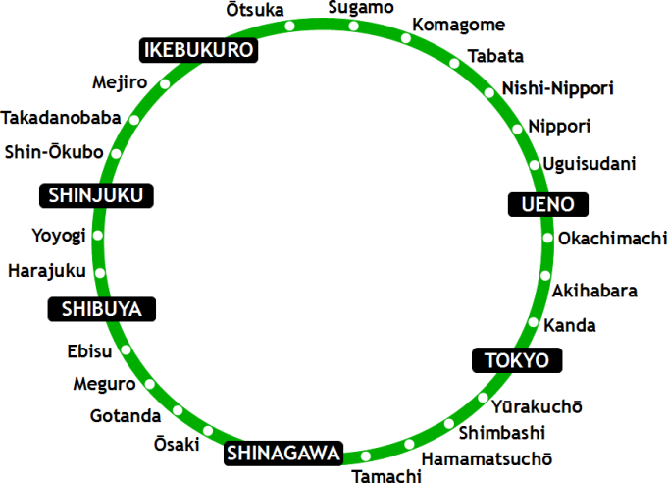
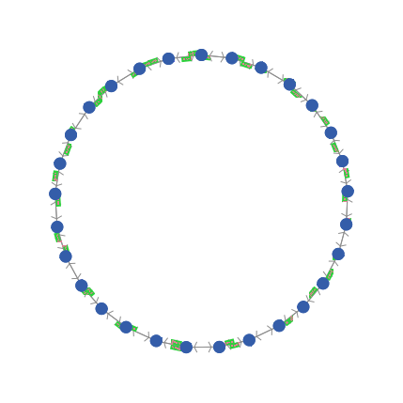

The real Yamanote Line route map. Large stations are boxed. Shinjuku is the busiest station in the world, followed by Shibuya and Ikebukuro
NetLogo model resembling the circular shape of Yamanote Line.

Model Overview
The model is consisted of three agents: trains, passengers and stations. Trains are the rectangular shape in green. They move along the track. Stations are represented by the blue dots. Passengers are inside stations and not visible.

Parameters
The following parameters allow the users to adjust the settings for the model.
- Initial number of passengers at each station: user could input a list of numbers into a textbox. The size of the list should equal the number of stations so that each item in the list corresponds to the initial number of passengers at each station
- Number of stations: Yamanote Line serves 29 stations in total. But the user working with other circular railway systems could input different values.
- Train intervals: user could set the time interval between two trains. When this number is set, trains are distributed uniformly along the line. As a result, the number of trains is also determined.
- Total time for each loop: A Yamanote Line train takes ~60 minutes to run a complete loop. The user could vary this value if working with another system or wanting to decrease the speed of train operations.
- Maximum capacity of train: the maximum number of people a train could take
- Passenger inflow rate per minute into each station: user could input a list of numbers. The size of the list should equal to the number of stations so that each number in the list corresponds to the passenger inflow rate of each station. The rate is generated using a Poisson distribution with the user input as its mean.
- Emergency Switch: when this button is pressed, all train movements stopped but passengers keep coming into stations. When the button is pressed again, trains start moving again.

Modeling Strategy
The model contains 3 major turtle agents: trains, passengers and stations. In the section below, I will describe how they interact with each other and how they are generated both on the high level and specific to each agent.
On the high level,
- Time: each real-world minute is represented by 1000 ticks.
- Trains: move in both counterclockwise and clockwise direction. The counterclockwise direction is called the “Outer loop” while the clockwise direction “Inner Loop” ². They travel at a constant speed along the track until hitting a station, where they stop, letting off passengers and taking in passengers and keep moving. Trains move every 100 ticks with each tick covering a distance of (Total Distance of Tracks) / (Total Time of Each Loop) / 10.
- Passengers: generated at the initial setup based on user input. They are also generated every 1000 ticks (per minute) at each station based on user’s input. Passengers wait at stations until a train comes and they board the train if the train is not full. If it’s full, they will have to wait for the next train.
- Stations: generated based on user’s input. They are evenly spaced from each other and form a loop automatically. Each station houses passengers. Stations are linked to the ones next to it in both directions.

On a more detailed level,
- Trains have the following variables:
  - Maximum capacity: the most number of people a train can take. A train could not take more than its maximum capacity
  - Capacity: the current number of passengers in a train. The number gets added and subtracted when train stops at a station based on the number of passengers who embark and disembark the train.
  - Running direction: inner or outer according to definition
  - Destination station: a list of equal size as the number of stations. Each item in the list corresponds to the number of passengers on the train heading to that station. When the train stops at station i, item i in the list clears to zero since all of the passengers heading to station i disembarks. When passengers embark, the corresponding item on the list increases based on which stations newly boarded passengers head to.
- Passengers have the following variables:
  - Destination: the station number that the passenger heads to. This number is generated randomly at the creation of the passenger and could not be the same station as the passenger is currently at.
  - Heading-direction: based on the destination that the passenger is heading to, the model calculates the closer direction that the passenger should pursue
- Each station has two breeds with the same variables. One of them is called “Stations”, representing the outer loop stations. The other one is called “Innerstations”, representing the stations on the inner loop. They could be better understood as two platforms at one station. Both have the following variables:
  - Station Number: the call number of a station. The “station” and “innerstation” with the same station number are in fact a part of the same physical station.
  - Outer loop capacity: the number of passengers at the “station” of a station. The number gets added and subtracted as an outer-loop train stops at “station” and passengers embark and disembark.
  - Inner loop capacity: the number of passengers at the “innerstation” of a station. The number changes similarly as the outer loop capacity

Result Analysis
I ran a set of two tests on the model to test how it performs. The first test is the reality check test, where I input the Yamanote Line data into the system and see it actually responds. The second test is the scenario test where I vary some of the parameters and see how the system responds. In the following section, both results will be presented and explained.

Reality-Check Test on the Yamanote Line
In the reality-check model, I modeled the morning rush hour on Yamanote Line which usually takes place from 6-8 AM each weekday.
The data on Yamanote Line is very difficult to obtain in a few reasons.
- Most of the data search was conducted in English; as a result, relevant data in Japanese do not appear
- Japanese agencies do not disclose information as much as the US agencies do. Many detailed data are not available to the public and need special request.
Consequently, I had to extract relevant information mainly through local news-source as well as transportation fan forum.

The first trial: I purposefully set all the parameters lower than the carrying capacity of the actual system to see if the system actually turns out to be unable to handle the situation as a result.
The list below describes the value for each parameter and how they are calculated:
- Initial station volume: each station is assigned 600 passengers to start with. This is because before the rush hour starts, a considerable number of passengers have gathered at the stations. Before 6 AM, the train frequency is low and as the time approaches 6, people gather at the station quickly and could be digested by the slow frequency of trains. We assume that at 6, train frequency increases to our set value.
- Number of stations: 29, the actual number of stations on Yamanote Line
- Train interval: 2 minutes, lower than the actual 1.5 minute interval
- Time each loop: 60 minutes, as the actual data
- Max Capacity of Train: the supposed capacity of train is ~1700, but in reality, trains carry 200% of its capacity at rush hours. We set it to 2000 here, but the actual capacity could be as many as ~3400. ³
- Passengers per minute: the assumption here is that each station handles 1/4 of its daily passenger flow during the morning rush hour and the number of passengers per minute is calculated by taking the hourly value divided by 60. ⁴ The exact value is hard to get, but the value used here is on the right scale.
The first trial result: the model responds as expected. It started off fine, but as time progresses, the system fails to contain the number of passengers in the system. As shown in the figures below, the number of passengers at one particular station increases 5 folds while the average waiting time per passenger increases unchecked. Note that the time suggests that model ran for 32 minutes. The setup fails to handle rush hour.
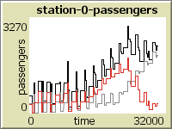
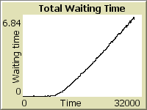

Station 0 Passenger change: over 32 minute period, the passenger volume 5 folded from 600 to 3200
Average waiting time / person: stable at first, increases linearly over time. At 30 minutes, a person needs to wait 7 minutes to ride a train
The Second trial: the model is set with parameters that resemble Yamanote Line more. More specifically, the following two parameters are changed:
- Train interval: 1.5 minutes, as the actual time Yamanote Line runs during rush hour
- Max capacity of train: 3000, closer to the ~3400 level mentioned above
The Second trial result: the result is consistent with the real world scenario where the system successfully handles the passenger volume. The number of passengers at a station is bounded at approximately 1600 and the average waiting time is kept around 1 minute. This is very ideal for travel. The model is ran over a period of 60 minutes.
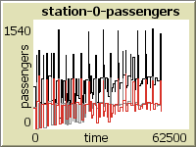
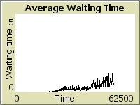

Station 0 Passenger change: over 60 minute period, the passenger volume is bounded.
Average waiting time: the waiting time slow increases, but at one-hour mark, it is just slightly above 1 minute, certainly acceptable for travelers.

Scenario Test on Yamanote Line
The next test I ran on the model is by varying the passenger per minute data to create a scenario.
The Third trial: In the morning rush hour, a sudden earthquake occurs so that every train stops running for about 5 minutes (5000 ticks). Then it’s back in service. Keeping the ideal setup of Yamanote Line, how does the system respond to the emergency?
In this trial, the emergency button is pressed at 30-minute mark and pressed again at 35-minute mark.
The Third trial result: If we keep the same setup after the earthquake as before, the system actually handles the situation. As shown in the figures below, number of passengers at station 0 stabilizes in ~10 minutes. The average waiting time for passengers, though, stays at a relatively high value since the trains are busy processing the leftover passengers remaining on platform, making the new passengers wait.
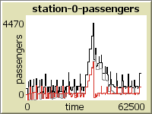
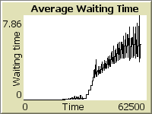

Station 0 Passenger change: the passenger volume peaks when the earthquake occurs. It then quickly settles down
After the earthquake, we expect a much longer average waiting time for passengers

The Fourth trial: During summer time in Tokyo, there are many firework displays at night and certain stations expect a sudden surge of passengers while others have fewer passengers. In this test, I hope to simulate that situation by giving one of the stations larger passenger-per-minute value. Specifically:
- The initial number of passengers at station 0 is 1000. Rest are 100.
- The passengers-per-minute at station 0 is 700. Rest are 30
- The max capacity of train is set to 2600 since the train is less likely to take as many people as in rush hour. People don’t mind waiting for the next train to come.
- Interval is set to 3 minutes.
The Fourth trial result: Station suffers sudden increase of passengers to 2000 in many occasions. This is 2x the original capacity. The average waiting time, though, stays stable.
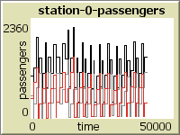
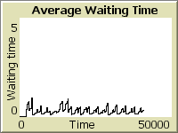
Station 0 Passenger change: the passenger volume varies dramatically based on which minute it is at the station
Average waiting time across the system, though, stays relatively low and stable

Value of the Model
In the system planning stage, it is not only costly but impractical in many cases to conduct real-word test runs on such railway system. The complex nature of passenger decision-making and generation makes mathematical models difficult to realize. Agent-based modeling, on the other hand, provides the mechanisms to handle such situations. By treating each passenger as an individual agent, each passenger makes his or her own choice, interacts with other agents, which in turn constitute a bigger picture.
Based on the current model, transportation planners could observe the reaction of the system under different circumstances without physically operating and experimenting with the actual system. Each circumstance requires no additional mathematical equations.
The model assists planners in many decision-making processes and allows different users to experiment different real-world data. More specifically, the model aims to answer the following important questions that railway planners face towards any railway system:
- What is the ideal frequency that trains should operate
- How passengers volume change at a particular change over time
- What carrying capacity a particular station should be designed to handle
- What is the crowdedness of trains
- How does a system responds to an interruption in service

Future Development
The current model provides the basic framework for a railway system. It simply possesses the most fundamental characteristics of a circular railway line. Many customization and expansion are possible for future development of this model, at the need of the users. The following provides some possibilities, but it is up to the user to modify the model to their best need.
In terms of result analysis:
- Total passenger passage over a particular section of the track
- The satisfaction level of each passengers based on the waiting time
In terms of model expansion:
- The distance between each station could be made customizable. Currently, it is assumed to be equally separated
- Additional lines and stations could be added arbitrarily by the user so that the model is expanded to cover much more complex railway systems. This expansion, however, is difficult
- Trains could be added arbitrarily to the existing system at designated location
- Addition of express trains that stop at certain stations. Planners might be interested if such service could improve the efficiency of the overall system.
- Better way of generating passengers’ destination: the method with which the destinations of the passengers are generated could be more flexible. Currently, it is a uniform distribution where each passenger randomly chooses a station as destination. Ideally, the model could take user-defined statistical numbers for the generation process.
- Modeling of Stations: stations could be modeled more individually as residential / business, etc so that passengers generated at each station assume more individuality
- Modeling of different scenarios: the model could have several built-in scenarios such as morning rush hour, evening rush hour and major event near a particular station. Planners might be more interested in seeing how the system responds in these particular cases.
Notes
- Wikipedia, under the entry “Yamanote Line”

- In reality, since trains travel on the left side in Japan, the counterclockwise direction is termed “inner loop” while the clockwise direction is termed “outer loop”. Note that this is the opposite of the term used in this report.

- The train capacity data is taken from a post from a forum from 2006. The train does get upgraded a couple of times, but the capacity does not vary too much. Source: http://www.skyscrapercity.com/showthread.php?t=418972&page=2

- Data taken from Japan Railway website: http://www.train-media.net/report/1110/jr.pdf. The report is in Japanese

