BeeSmart: A Scientific Inquiry Curricular Unit for Learning Complex Systems Through Honeybees’ Hive-Finding Behavior with HubNet Participatory Simulation and NetLogo 3D Multi-Agent Modeling
By: Bryan Yu Guo
Professor: Uri Wilensky
Course: EECS 472 Designing and constructing models with multi-agent languages
Northwestern University

BeeSmart: A Scientific Inquiry Curricular Unit for Learning Complex Systems Through Honeybees’ Hive-Finding Behavior with HubNet Participatory Simulation and NetLogo 3D Multi-Agent Modeling
Abstract
BeeSmart is a NetLogo-based curricular unit for learning complex systems principles through honeybees’ hive finding behavior. In this paper, I report the second iteration of the design of this curricular unit, focusing on two newly designed models—BeeSmart HubNet Model and BeeSmart Waggle Dance 3D Model—based on the results of a pilot study in a high school using the original curricular unit. The 3D model is designed to help connecting 2D and 3D representations, and the HubNet model is designed to demonstrate interactions among agents. Students had the most difficulties with these two aspects in the pilot study. This iteration of the unit intends to address these difficulties.
Introduction
BeeSmart is a scientific inquiry curricular unit for learning complex systems through honeybees’ hive-finding behavior. The goal of this project is to help students learn complex systems concepts that cut across multiple scientific disciplines in order to provide students with organizing frameworks for science learning.
In this paper, I first review the literature of learning complex systems and the affordance of multi-agent modeling and participatory simulation, and then introduce the motivation of this iteration of the BeeSmart curricular unit. I then describe the BeeSmart Waggle Dance 3D Model and the BeeSmart HubNet Model and, followed by describing two rounds of user testing of the HubNet model.
Background
The study of complex systems is an emerging field of science on how interaction among numerous parts of the system gives rise to the overall behavior of the system. Many traditionally segregated science subjects in schools can be unified if taken as complex systems. Complex systems concepts, such as multi-agent, positive feedback, and decentralized control are powerful ideas to understand complex systems across domains.
Learning complex systems concepts is important for both scientific and pedagogical reasons (Goldstone & Wilensky, 2008). However, research show that these concepts are difficult for students to learn (e.g. Wilensky and Resnick, 1999; Penner, 2001; Chi, 2006). One major difficulty is the “deterministic centralized mindset” (Wilensky & Resnick, 1999). Typically, students take randomness that involved in complex systems as destructive processes that cause undesirable consequences. In fact, randomness in a large group can create pattern and order. In addition, students usually project their own experience of actively planning and designing onto agents in complex systems. However, non-human agents possess much less intelligence and usually cannot actively plan. However, by pooling their limited abilities, they can achieve highly complex goals as a group. But students tend to confuse the agents’ ability with the group’s ability.
BeeSmart is based on honeybees’ hive-finding phenomenon and intensive research literature on swarm intelligence. Seeley (2010) described how a swarm of ten thousand honeybees accurately choose the single best hive site. The swarm’s decision-making process is best explained through a complex systems lens. The system consists of multiple agents that obey simple behavioral rules: if a scout bee discovers a potential hive site, she inspects it. Then she goes back to the swarm and reports the quality, or the suitability, of the site by doing a waggle dance, which is their medium of communication. Bees have the instinctual ability to objectively assess the quality of potential hive sites. If the quality is high, she dances enthusiastically for a long time to advertise it; if the quality is low, she makes a brief lackluster dance or does not dance at all. This can bee seen as encoding meaning into signals: the longer the dance, the better the site, and the stronger the signal. Because dances for higher quality sites are presented in the swarm for longer time, neutral scouts (those who have not committed to a certain site) in the swarm are more likely to see such dances. When they see a dance, they become recruited and proceed to inspect the advertised hive (See Figure 1).
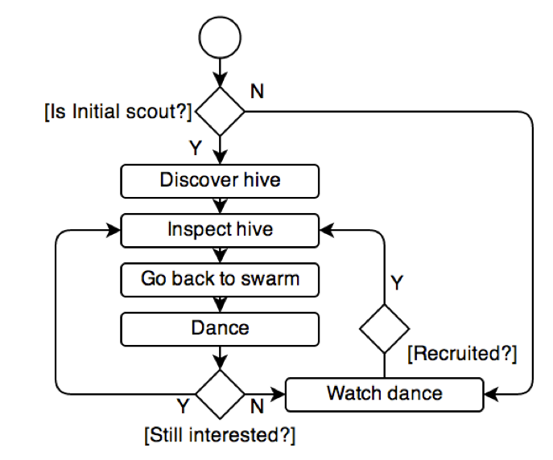
Figure 1. A Bee’s Routine in the Hive Finding Process.
Such simple behavior and interactions between dancers and observers at the micro level results in a positive feedback loop: signals advocating high quality hives are amplified.
The BeeSmart pilot study provided additional evidence to this DC mindset. In the pre-test, students showed both the deterministic and the centralized mindset. While learning the first version of the curricular unit, randomness became a focal point of the class discussion. Students discovered that randomness is involved in multiple aspects of the Hive-Finding Model (Figure 2), such as the movement of the bees and the layout of the world. However, they were not able to notice the randomness involved in bees’ interactions in the swarm. When asked to explain bees’ interactions, students answered that the bees (intentionally) look for better dances, which represent better hive sites, as opposed to the fact that bees randomly follow a dance near by. Because the dances for better sites last longer, by randomly following a dance, a bee is more likely to follow a dance that is advocating for a better site than a worse site.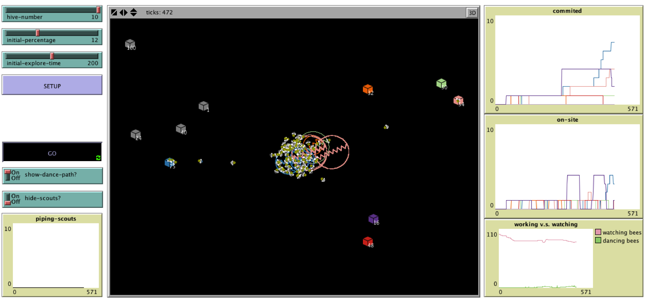
Figure 2. BeeSmart Hive-Finding Model. It demonstrates the whole phenomenon pattern, but it is hard to understand the interactions among bees in the swarm at the center.
In addition, students had difficulties understanding the original Waggle Dance Model. A scout bee’s waggle dances encode three types of information: the direction, the distance, and the quality of the hive site a bee advocates. It is a complex representational system, as it encodes the direction in relation to the sun. bees perform waggle dances on the surface of the swarm, which is perpendicular to the ground.
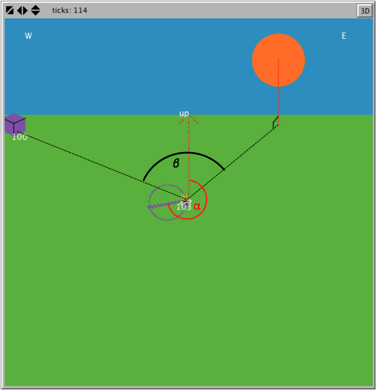
Figure 3. The Original 2D Waggle Dance Model
As shown in Figure 3, the dance patter (the purple circle with a squiggly in the center) is on an imaginary vertical plane. The angle between the up direction and the squiggly (shown as supplementary angle of alpha, the angle between the squiggly and the red arrow pointing up) is the same as the angle between the sun and the hive site. However, to calculate this sun-swarm-site angle (beta), the sun’s position needs to be projected to the ground. The frequent plane switching made students’ understanding of waggle dances more difficult.
To address these difficulties, I designed two new models, BeeSmart HubNet Model and BeeSmart Waggle Dance 3D Model.
Design and Theoretical Frameworks
Jacobson and Wilensky (2006) proposed five design principles for learning complex systems, which include 1) experiencing complex systems phenomena; 2) making the complex system conceptual framework explicit; 3) encouraging collaboration, discussion, and reflection; 4) constructing theories, models and experiments, and 5) learning trajectories for deep understandings and explorations.
The design of the original BeeSmart unit adopted all but the last principle, the scope of which is much larger than a single curricular unit. In the second round of iteration, I make more salient the first principle by allowing students to experience the phenomenon from the perspective of honeybees through the HubNet infrastructure of NetLogo.
HubNet is a NetLogo based participatory simulation that allows students to act out the roles of individual system elements and see how the behavior of the system as a whole can emerge from these individual behaviors (Wilensky & Stroup,1999. By giving control of agents to students and making students see the system from agents’ perspective, HubNet architecture makes overt and visible students’ strategies in relation to generating different kinds of emergent behavior. Such approach provides students powerful experience fighting against the DC mindset. Students no longer have access to the global information of the system and cannot play God. Instead, they see how limited information and choices individual agents in the system have, and how the overall pattern can still emerge through the interaction among agents, regardless all the limitations each individual has.
HubNet-based participatory simulation is promising in helping students understand honeybees’ decision-making process. In the pilot study, students tends to project their human experience with selecting the best choice from multiple choices, explaining that the bees watch and compare multiple dances and follow the best one that they could find. Giving students the perspective of honeybees will help them understand that they can only see a few of other bees around them, and it is impossible to search or compare multiple dances to find out the best one. Instead, they can simply follow a dance that’s round them, and the dance that they follow is more likely to be for a better hive site because those dances last longer. Repeating such process can eventually lead to the system’s selection of the best hive.
NetLogo 3D version makes possible simulating a 3D space. When the target phenomenon is represented in 3D, students can rotate the world and perceive the special relationship between different objects. Existing literature in visualization shows that simply moving from 2D to 3D does not necessarily increase users’ understanding. To the contrary, higher dimensions may cause users feel more “cluttered” and less efficient (e.g. Cockburn & McKenzie, 2002). Therefore, simply converting the BeeSmart Waggle Dance 2D Model to a 3D model does not guarantee better learning outcomes. It is important to help students bridge the real world and the 3D representation in meaningful ways so that they can make better sense of the problem represented.
BeeSmart Models and Activities
BeeSmart HubNet Model
The learning goals of this HubNet activity is to understand:
- individual bees have access to only local information
- individual bees’ randomly following a dance (as opposed to intentionally choosing a better dance) can still cause the right result to emerge
- the system is robust and redundant
To achieve these learning goal, I designed the HubNet model as described below (See Figure 4). 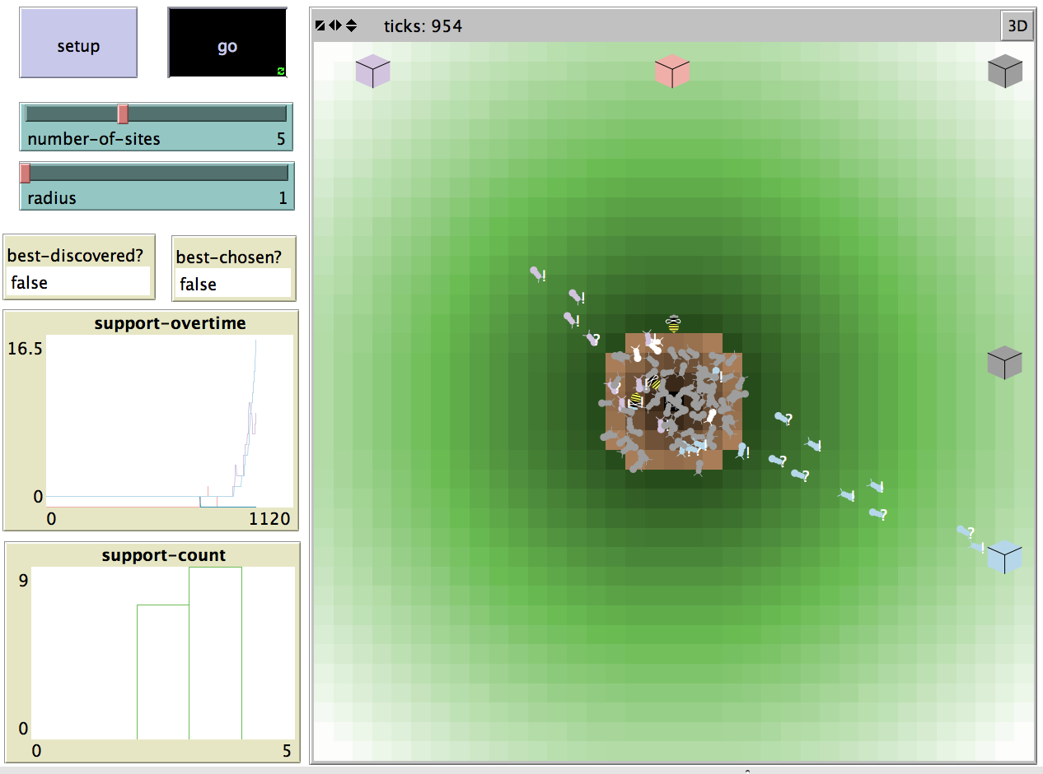
Figure 4. BeeSmart HubNet Model Host View

The view in the model has a bee swarm in the center and a few potential hive sites around the swarm. When clients join the server, each of the clients is represented as a bee-shaped agents. The androids are represented as bug-shaped agents. They follow the same rules as the human-controlled bees, except that human-controlled bees can explore the environment under the control of the students.
The androids are programmed to follow the following rules:
At each tick, androids move around randomly by turning a random angle between [-15 15] and forward a random-float number that is less than 0.1. It also sees if there is any dancing agents within one step and is in its 30 degree cone of vision. If there is, the android may follow the dance based on a probability that is calculated according to the interest of the dancer. If the android decides to follow the dance, it sets its target as the target of the dancer, and fly out to evaluate the hive site that the dance is advocating by facing the target and forward one step at each tick. When the site is within 3 steps and 120 degree of the android's cone of vision, the android sets its interest as the quality of the hive and fly back to the swarm to dance for it.
Students basically follow the same set of rules as androids, except for a few decisions that the clients can make: when the model starts, students needs to "fly" out of the swarm in order to discover new potential hive sites. Students can control where their bees go by using the directional buttons on the clients (See Figure 5). When stumbled upon a site, students can go back to the swarm and press the dance button to perform dances in order to promote the hive they discovered. As a bee dances, her interest declines. when the interest reaches zero, the bee stops dancing. At this point, students can choose if they want to fly out and explore another hive or to stay in the swarm and follow other bees dances. They can follow other dances by clicking other dancing bees. Once a dance is selected, the bee automatically flies out to the site the dance was advocating, investigates the site, and flies back to the swarm. Then the student can decide whether to dance for the site or to follow another dance.
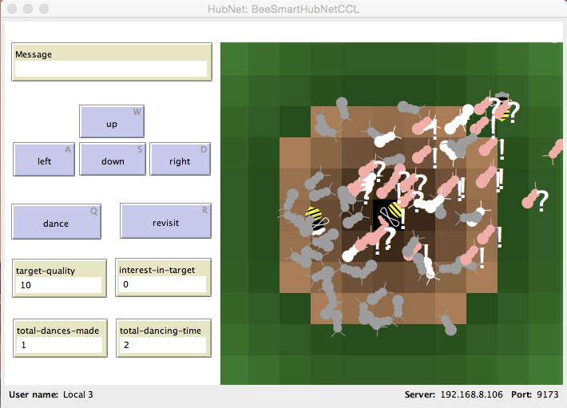
Figure 5. BeeSmart HubNet Model Client View with Vision Radius Equals Five.

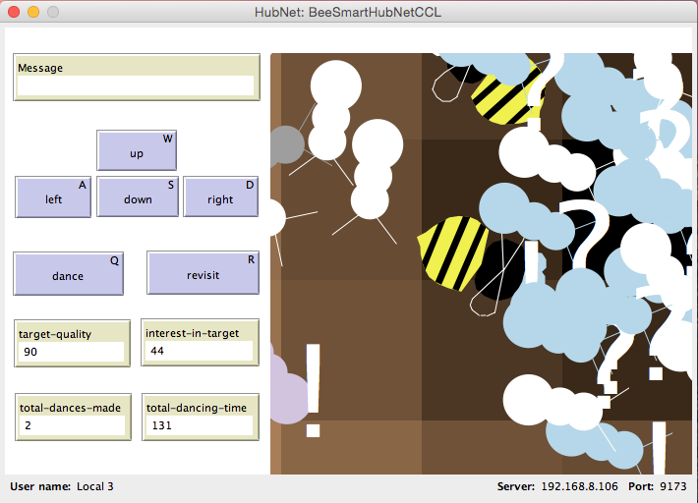
Figure 6. BeeSmart HubNet Model Client View with Vision Radius Equals One.
Below, I also describe the potential learning experience from one students’ perspective:
- In the first round, the student can see the whole world on his/her client
- The student can talk to (not in the hubnet, but in the physical room where the activity is implemented) other students to coordinate the decision making. Students will find this task easy because the have access to the global information and can use language to exchange information that is not immediately visible in the world.
- In the second round, the students are not allowed to talk to each other (because bees don’t talk to each other), the only way to communicate is through waggle dances. Students will find the task more difficult but should still be able to achieve it because they can see everything going on in the world.
- In the third round, the teacher constrains students’ field of view so that they can only see two steps away from themselves (See Figure 6). In the mean time, students are not allowed the talk. This makes the task impossible to achieve by using their existing methods (informed decision making) because they don’t have access to the global information nor can they talk to exchange information. This forces students to see what a bee can see, and experience the limitation of cognitive and physical constrains of a bee.
- The limitations force students to make uninformed, imperfect decisions (following random dances, or better dances in a very limited range). There is no guarantee that the dances students followed are the best, or even better dances. The students would be surprised that even they make such imperfect decisions, their decisions can still converge on the highest hive because dances for better hives last longer and are more vigorous, which are more easily to see and are more likely for bees to follow.
BeeSmart Waggel Dance 3D Model
The BeeSmart Waggel Dance 3D Model represents a 3D world depicted in the left part of Figure 7. At the center, there is a warm of bees. The sun is at the upper right corner. Suppose a new hive site is in the trees at the lower right corner. The 3D model can represent the special relationships among these objects in high fidelity. The right part of Figure 7, shows a close mapping of the real world situation, with a swarm at the center, the sun at the top right corner, and a hive site at the lower right corner. In the 3D model, students can control the position of the sun, which represents different time of the day. Students can also change the position of the hive site to experiment with the relationship between the waggle dance pattern and the physical layout.
If a bee makes a waggle dance on the vertical plane in the swarm, the waggle dance would point to the right (about 90 degree to the right of the “up” direction). This prediction is hard to imagine because it involves multi steps of mental rotation. To help students bridge the waggle dance representation with the physical layout in the 3D world, BeeSmart Waggel Dance 3D Model allows students to collapse the 3D world to a 2D plane. When the “one-plane” button is pressed, the sun and the swarm sink to the ground, showing clearly the meaning of the sun-swarm-site angle (See Figure 8 Left). After this conversion, the bee also makes a clone of itself. The original bee dances on the vertical plane, while the clone dances on the ground. In the ground dance, the up arrow (the blue arrow on the swarm and on the ground) is rotated towards the sun, so the squiggly in the dance pattern is pointing to the hive site (See Figure 8 Right). Such conversion and rotation make explicit the relationship between the waggle dance pattern and the layout of the physical world.

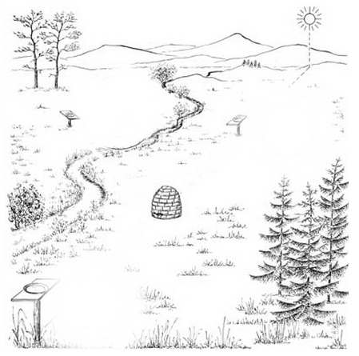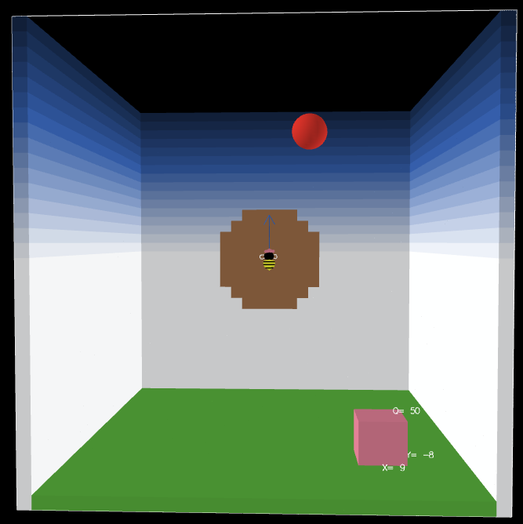
Figure 7. A Honeybee Swarm with the Sun in the Real World.
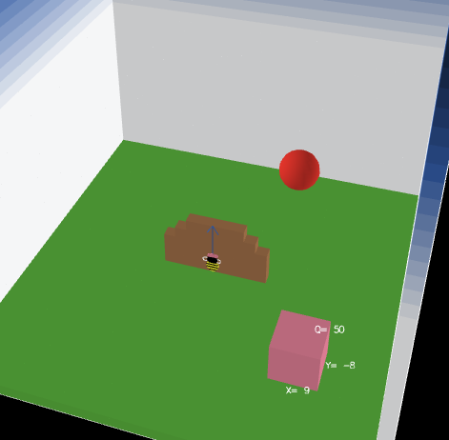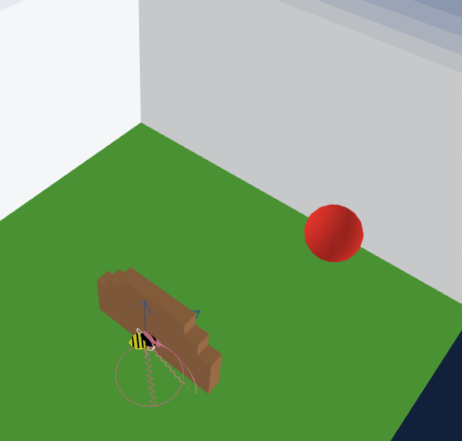
Figure 8. Collapsing a 3D space into a 2D plane.
User Testing
I conducted two rounds of user testing of the HubNet model. The first round was with three graduate students. The test lasted one hour. The second round was with 14 people, a mixed group including faculty members, graduate students, and software developers. The test lasted 40 minutes.
Here I focus on reporting the first test. Three graduate students were sitting around the same table and were allowed to talk. In the first run, the students were given a vision radius of 5, which allowed them to see the whole swarm but not the whole world. The students communicated intensively through talking, attempting to know get more detailed knowledge about the world and about each other. They asked “which one are you”, “where are you”, and “what color are you” in order to locate each other and to compete with each other. Students complained about the model being “laggy”, the confusion of similar site colors, and the difficulty of telling which bees they were controlling because bees sit on top of each other.
After a few runs with the same setting, the vision radius was decreased to 1, giving access to students only a tiny part of the swarm. In addition, students were told not to talk to each other so that they don’t have access to additional information beyond what is given through the clients. Interestingly, students commented that they followed more bees and enjoyed the experience when they were not allowed to talk. They also said that the shorter vision radius made them pay closer attention to the color and the interactions among the bees.
The user test shows that the design achieved its goals when students said “Before, you can see the entire hive. Basically you could see obviously what bees are dancing. But if you are a bee dancing, it’s not like you can look around seeing all the other bees, so that makes you want to follow bees to their hives no matter if it’s better or worse”.
In addition, based on observations and asking for students’ feedback, the following changes are made:
Bugs discovered and fixed after this round of user testing:
- Fixed perspective reset problem
- Fixed the problem of not being able to click on androids to follow their dance
- Fixed the bars order in the histogram
- Fixed miscalculation of the best site quality
Features added or modified after the first round of user testing:
- Constrained the clients’ ability to explore more than one hive site on one trip.
- Deleted the “Adding Android” button and hard coded it into the setup procedure to avoid forgetting adding androids when starting the model.
- Used a color list for the hives sites to ensure sufficient difference among all the sites.
- Changed the names of the monitors on the clients to make their meanings more clear.
- Added a waiting period after each dance to avoid picking up the same dance again too quickly.
- Added a plot to reflect the overall trend of the swarm overtime in addition to a histogram that reflects the instance change in the swarm.
- Changed the arrow key button shortcuts from SDFE to ASDW to align with existing gaming conventions.

References
Chi, M. T. (2005). Commonsense conceptions of emergent processes: Why some misconceptions are robust. The Journal of the Learning Sciences, 14(2), 161–199.
Cockburn, A., & McKenzie, B. (2002). Evaluating the Effectiveness of Spatial Memory in 2D and 3D Physical and Virtual Environments. In Proceedings of the SIGCHI Conference on Human Factors in Computing Systems (pp. 203–210). New York, NY, USA: ACM.
Goldstone, R. L., & Wilensky, U. (2008). Promoting Transfer by Grounding Complex Systems Principles. Journal of the Learning Sciences, 17(4), 465–516.
Jacobson, M. J., & Wilensky, U. (2006). Complex systems in education: Scientific and educational importance and implications for the learning sciences. The Journal of the Learning Sciences, 15(1), 11–34.
Penner, D. E. (2001). Complexity, emergence, and synthetic models in science education. Designing for Science, 177–208.
Seeley, T. D. (2010). Honeybee democracy. Princeton, NJ: Princeton University Press.
Wilensky, U., & Resnick, M. (1999). Thinking in levels: A dynamic systems approach to making sense of the world. Journal of Science Education and Technology, 8(1), 3–19.
Wilensky, U., & Stroup, W. (1999). Learning through participatory simulations: Network-based design for systems learning in classrooms. In Proceedings of the 1999 conference on Computer support for collaborative learning (p. 80). International Society of the Learning Sciences.
Appendix
The following instructions were given to the users
Introduction
- This model simulates honeybees’ hive finding behavior (http://ccl.northwestern.edu/beesmart)
- The view in the model has a bee swarm in the center and a few potential hive sites around the swarm
- You control one of the scouts and see the world through her perspective
- You can interact with each other and with the androids
Your Goal
- Your goal is to help the whole swarm to find the best hive site.
Things You Can Do
- You can move around by clicking on the direction buttons or by pressing the hot keys.
- You can click on a dancing bee to explore the hive site she’s advocating.
- If you have visited a site, when you are back in the swarm, you can make a dance for it.
- You can revisit the site you just visited by pressing the “revisit” button.

