Asmaa Aljuhani
Professor Wilensky
EECS 372
June 3, 2013
Aquaponics system
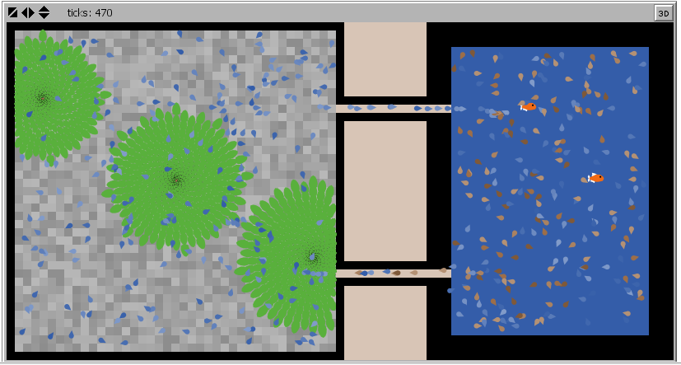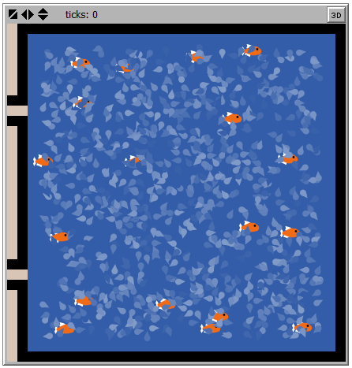

Changes from last version:
Feeding mechanism is added.
The details model focus on the tank part.

Agent behavior:
Feeding mechanism is added. Food are represented by turtles. There are controllers to control how frequently you feed fish and the amount of food per fish.Based on that, I added an attribute for fish to control the amount of food each fish can eat, otherwise they’ll eat with no stop.

System behavior: The model now represents the full features of the ecosystem.
Each tick:
Fish:
I Swim in the tank
I eat food
I waste

Water:
I move within the tank
I carry fish waste
If I reach the tunnel
I cross the tunnel to the growbed
I aggregate plants
I got filtered by the plant
If I reach the tunnel
I cross the tunnel back to the tank
Plants:
If I encounter water
I grow
I filter water
Food:
Each day (100 tick):
I am added
If I am not eaten by fish
I turn to toxics

Next steps:
For the details model: I’ll add the bacteria. If time permit, I might consider applying for the poster contest for this conference (due June 7) http://www.uwsp.edu/conted/ConfWrkShp/Documents/IACPosterContestFlyer.pdf.

